CORRECTION NOTICE
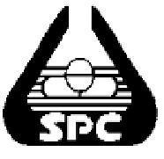

STATE PHRAMACEUTICALS CORPORATION OF
SRI LANKA

TENDER NO : DHS/SS/ICB/198/2027 CLOSING DATE : 11/05/2026

Please note that the Item No.3 SR No. should be corrected to read as 20300725 instead of 20300705.

Regret any inconvenience caused in this regard.

CHAIRMAN
STATE PHARMACEUTICALS CORPORATION OF SRI LANKA
“MEHEWARA PIYASA” 16TH FLOOR, NO. 41, KIRULA ROAD
COLOMBO 5.

